**Hall Of Fame**

CO_18 College module- Hall of Fame- Present unicorns -Need to change same size and same font size for all students data

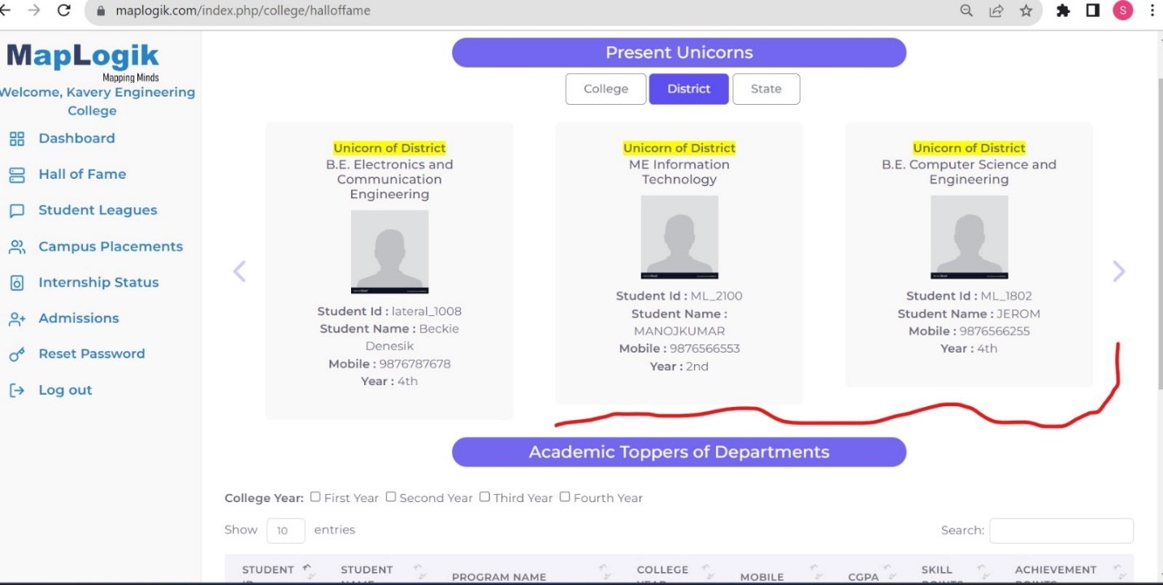

CO_08 In college Module- Hall of Fame- In present unicorns-we should give the same space for "No Records Found" in college, district and state as we have data in those sections.

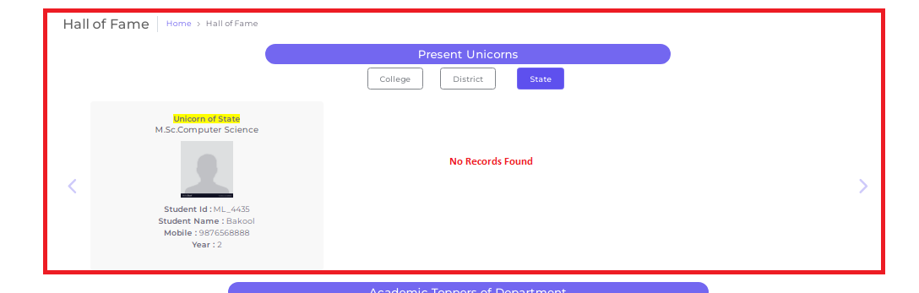

**COLLEGE DASHBOARD**

**CO_23** In college module- dashboard card data’s are showing wrong

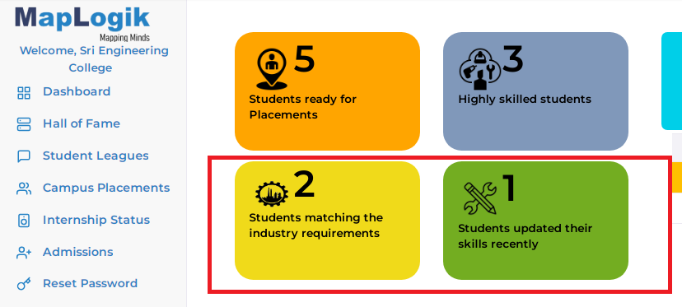

**Logic: Students are matching the industry requirements**

Following are the factors to be considered:

* Students with more than 60 % in academic and those students with 2 star rating – ( 3 or 4 skills completion )
* No arrear students

**Students have updated their skills**

Students who have got 1 star rating- (2 skills completion)

No arrears students

Students updated their skills in the last 30 days

**CO_29 Colleges visibility comparison chart-**

**In GRAPH chart SOME college names are NOT**

**Showing**

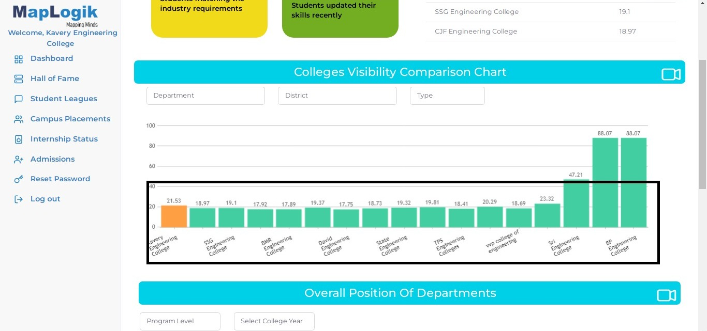

**COLLEGE MODULE-INTERNSHIP**

CO_28 In college module- Internship status- general internship and skill matching internship number of student hyperlink is not working, once I click 1 value should show student details.

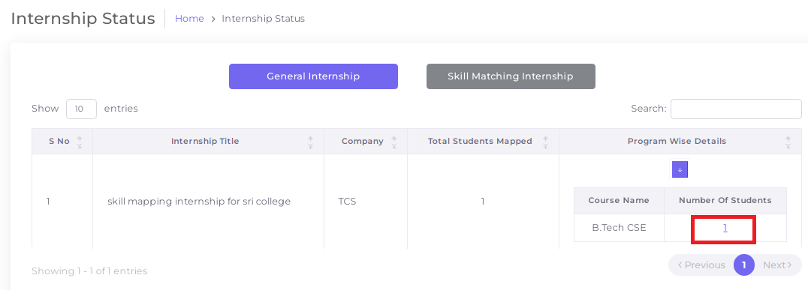

CO_29 In college module- Internship status- once I click General Internship and skill matching Internship button should show Total No. of Students Mapped in table header.

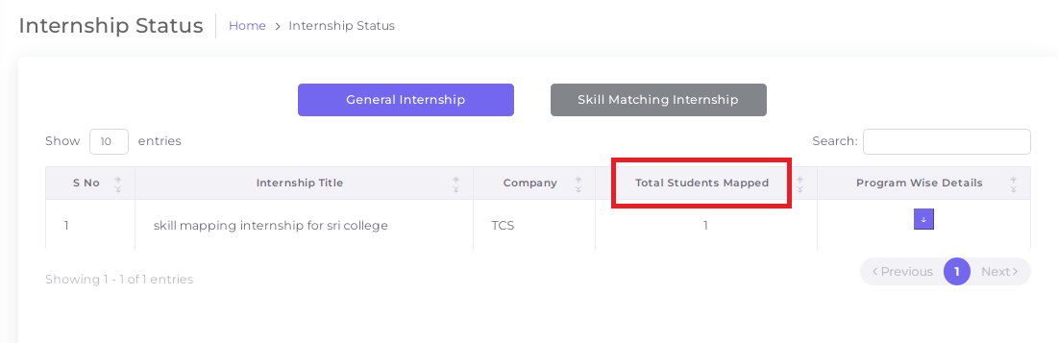

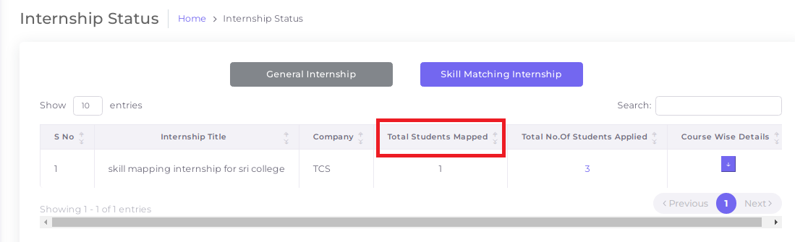

CO_31 In college module- internship status- once posting a general internship and skills internship in company module means not showing details in internship status

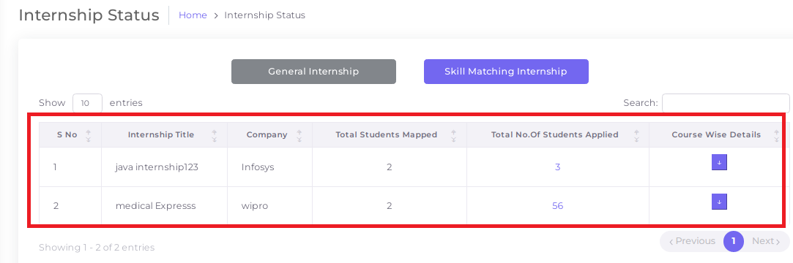

**CO_32 In college module-internship status- skill matching internship- once I click the skill matching internship means not showing 3 student details it shows only one**

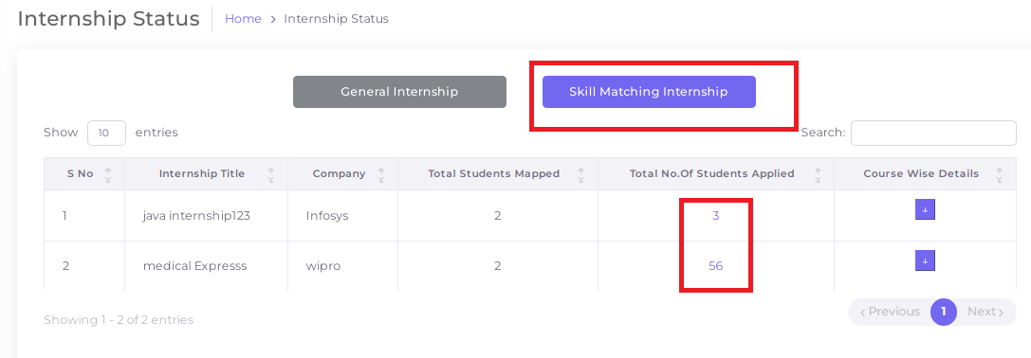

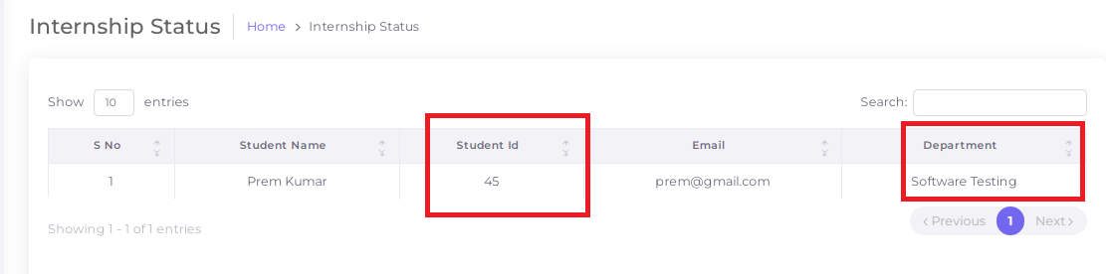

**Campus Placements**

**CO_34 In Campus placement and direct company call- students shortlisted list option should be open and close**

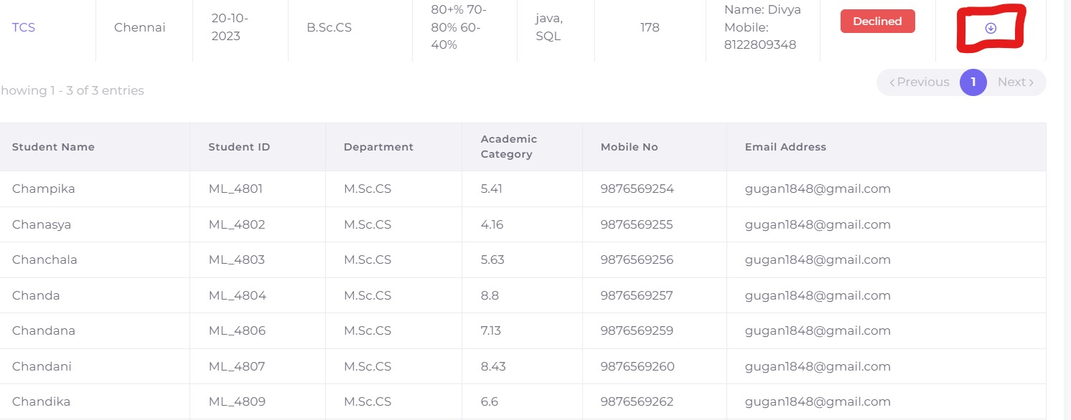

**CO_35 In campus placements and Direct company call shortlisted list -Shortlisted students for campus recruitment , Need department and academic category filter**

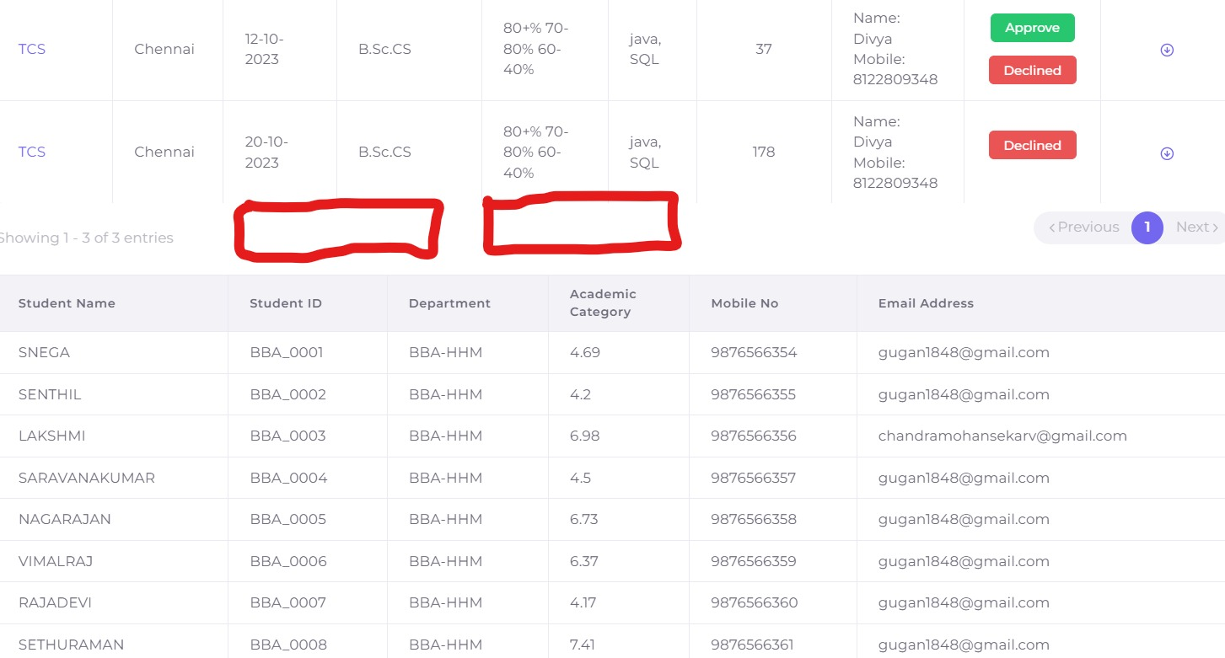

**Design**

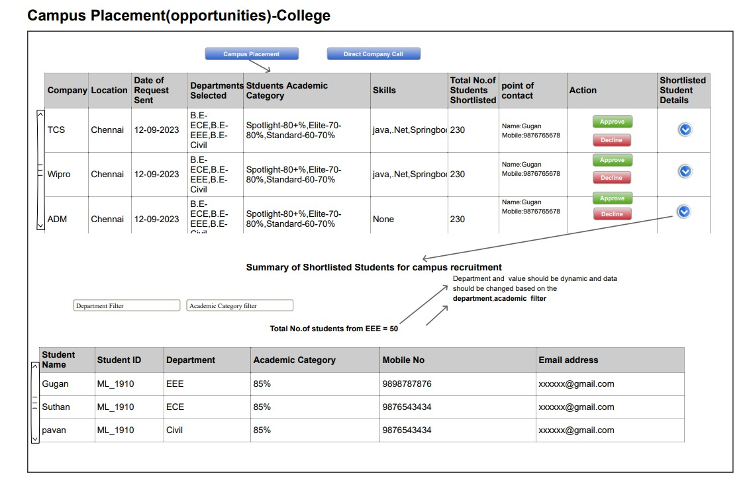

**CO_36 In campus placements and Direct company call shortlisted list -Add Total No.of Students From EEE-50**

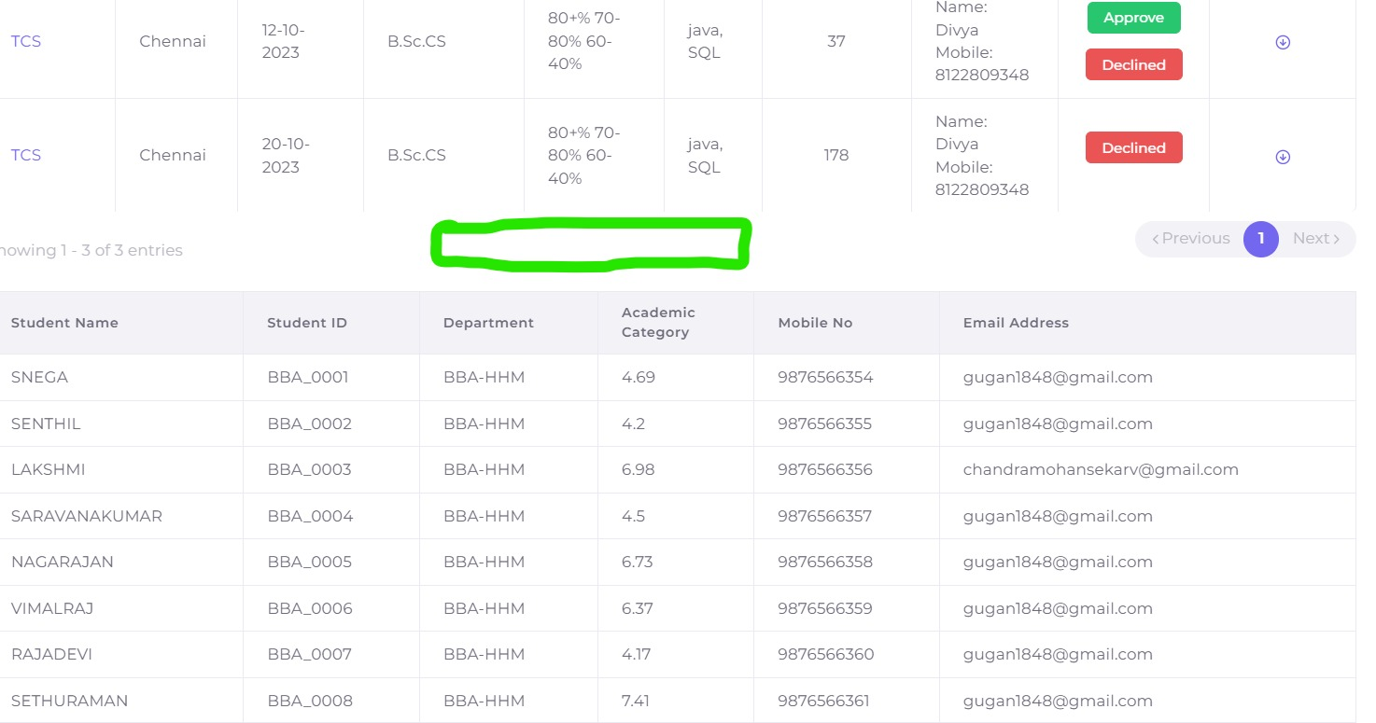

**CO-37 Direct company call- Direct company call button is not working**

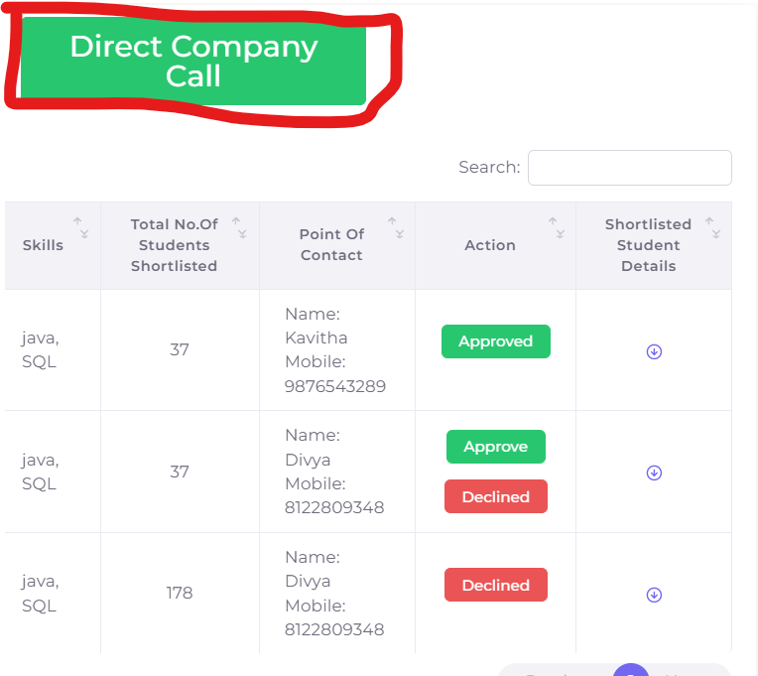

**CO-37 Direct company call- once click a student name navigate to student preview in student profile pic**

